Data Visualization and Experimental Mapping in Tableau
1. Introduction
Using the crypto_analytics MySQL database environment, that Antigravity created in project 3, the next objective was to convert the calculated metrics into actionable business intelligence. A direct connection was established between the MySQL analytical views and the Tableau visualization platform. While the MySQL backend efficiently calculated all the math, Tableau was used perform visual aggregations, advanced dimension sorting, and graphic rendering required by the client specifications.

2. Tableau Configuration and Mapping Strategy
There is a deliberate one-to-one relationship between the client goals and the final Tableau visual layout:
Goal 1: Distribution of Finish Times (Execution Latency)
Evaluates whether settlement delays represent white noise or cluster inefficiency.
- Tableau Implementation: Vertical Bar Chart.
- How I did it: The rounded_settle_delay dimension was dragged to the Columns shelf and frequency was dropped onto the Rows shelf. Tableau grouped the pre-calculated delays from MySQL into a smooth visual probability curve.
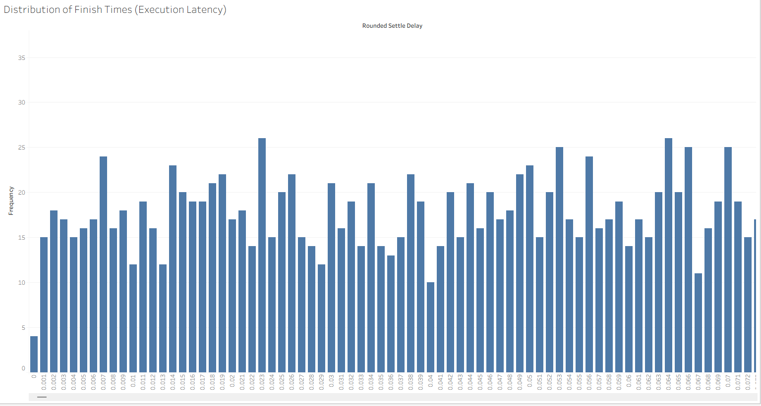
Goal 2: Top 10 Most Traded Symbols by Volume
Determines the most robust data points for statistical profit validation.
- Tableau Implementation: A Sorted Horizontal Bar Chart.
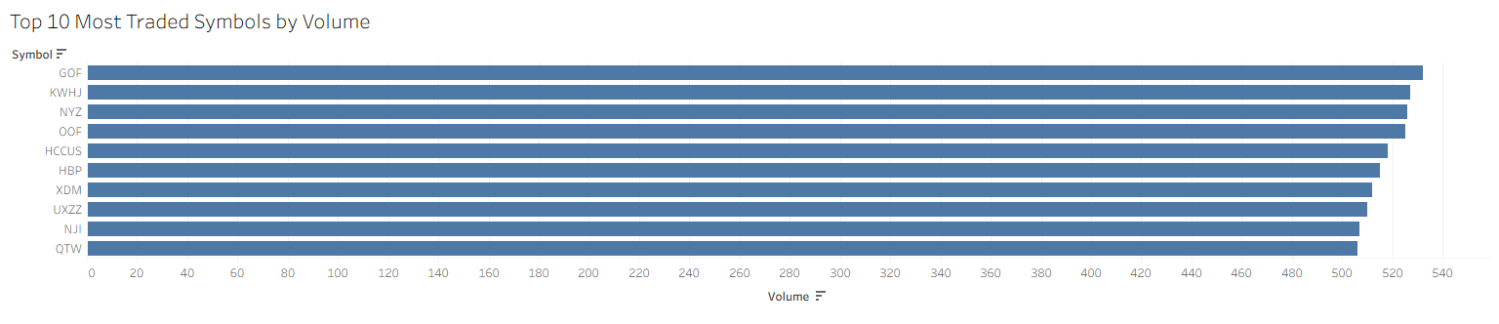
- How I did it: The symbol dimension was placed on Rows, and the volume measure on Columns. Tableau's descending sort feature was used to rank the assets visually. The MySQL view had already capped the query limit at 10.

Goal 3: Time Series of Mean Finish Times (Speed Changes)
Tracks execution speeds across standardized hourly chunks to detect latency degradation over time
- Tableau Implementation: A Time-Series Line Chart.
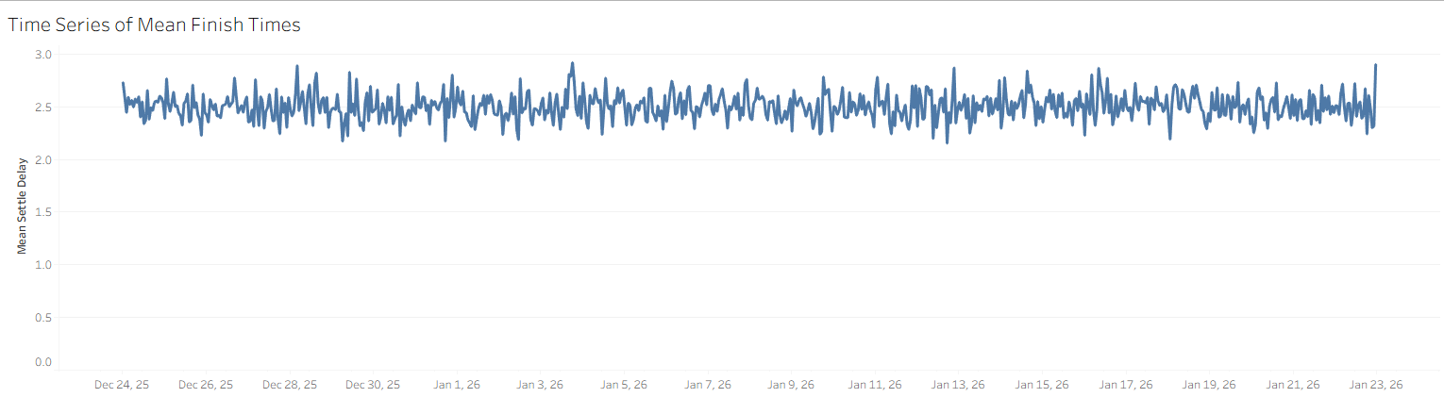
- How I did it: The bid_hour was configured as a Continuous datetime dimension on the Columns shelf. The mean_settle_delay measure was placed on the Rows shelf. This visualized the performance trend lines progressing chronologically through the dataset.

Goal 4: Fastest Finishing Trades (The Theoretical Limit)
Extracts the bottom 1st percentile of latency to establish an absolute system baseline
- Tableau Implementation: A Packed Bubble Chart.
- How I did it: The symbol dimension and absolute_fastest_delay measure were highlighted simultaneously in the Data pane. The 'Packed Bubbles' visualization was then selected from the 'Show Me' menu, prompting Tableau to automatically assign symbols to the color/text marks and dynamically scale the physical size of the bubbles relative to their absolute execution delays.
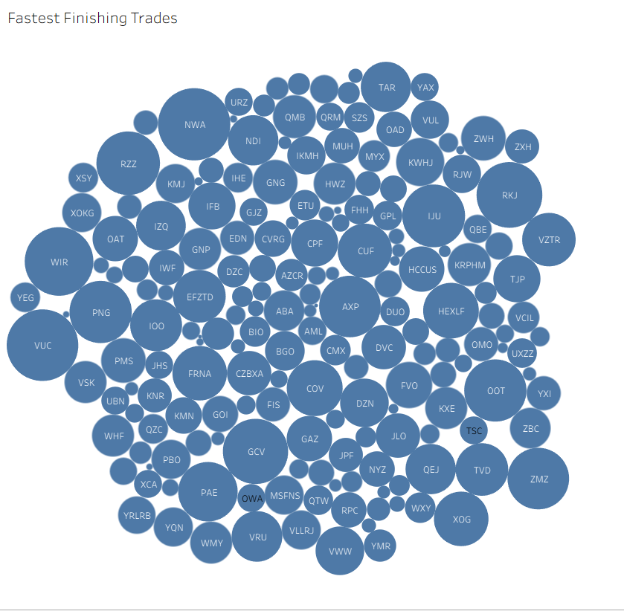

Goal 5: Daily Volume Histogram (System Load Analysis)
Profiles peak system loads to identify anomalies outside the margins of standard variance.
- Tableau Implementation: A Discrete Vertical Bar Chart.
- How I did it: The trade_date dimension was deployed to the Columns shelf (configured as an Exact Date and Discrete value), and the transaction_count measure was assigned to the Rows shelf. This instantly generated a daily volume histogram.
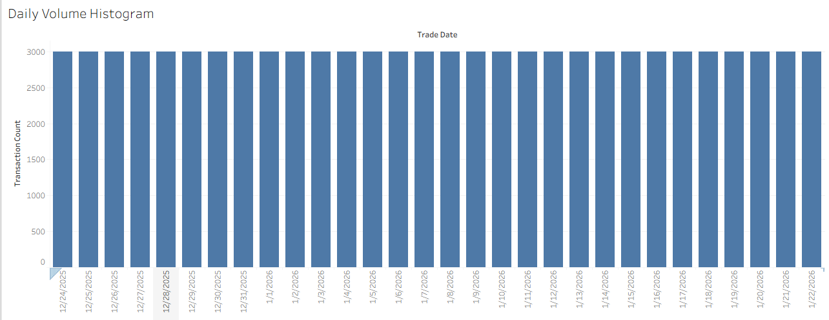

3. Conclusion
By using Tableau with the MySQL views, visuals were able to be created seamlessly because Tableau didn’t have to handle any math or calculations as MySQL handled it. The only thing Tableau handled was sorting, filtering and making the data look like what the client asked for. Using both Tableau and MySQL helped me grab clear insights without any additional computations.

